Course-End Project
Implementing microservices with CodePipeline and ECS

Steps to be followed:
- Set Up Docker and GitHub Repositories
- Deploy Services on Amazon ECS
- Automate CI/CD with AWS CodePipeline

Step 1: Set Up Docker and GitHub Repositories
- Navigate to GitHub to access the GitHub repositories for both Backend (NodeJS) and Frontend (React) applications
https://github.com/anujdevopslearn/ReactFrontend.git

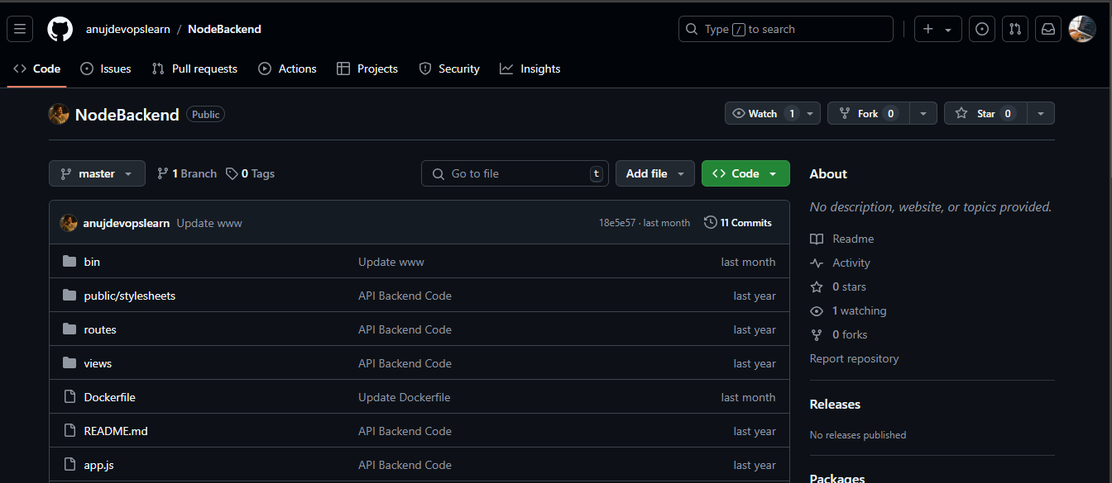

- Create Dockerfiles for both services with the following configurations and push them to the respective repositories:

Backend Dockerfile:

FROM node:16
ENV HOME=/home/app
COPY package.json $HOME/node_docker/
WORKDIR $HOME/node_docker
RUN npm install --silent --progress=false
COPY . $HOME/node_docker
EXPOSE 3000
CMD ["npm", "start"]

Frontend Dockerfile:

FROM node:16
ENV HOME=/home/app
COPY package.json $HOME/node_docker/
WORKDIR $HOME/node_docker
RUN npm install --silent --progress=false
COPY . $HOME/node_docker
EXPOSE 3000
CMD ["npm", "start"]

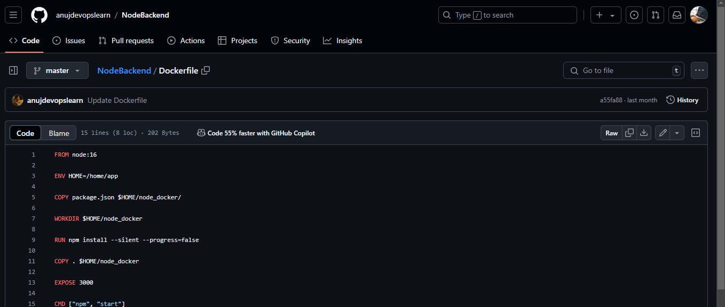

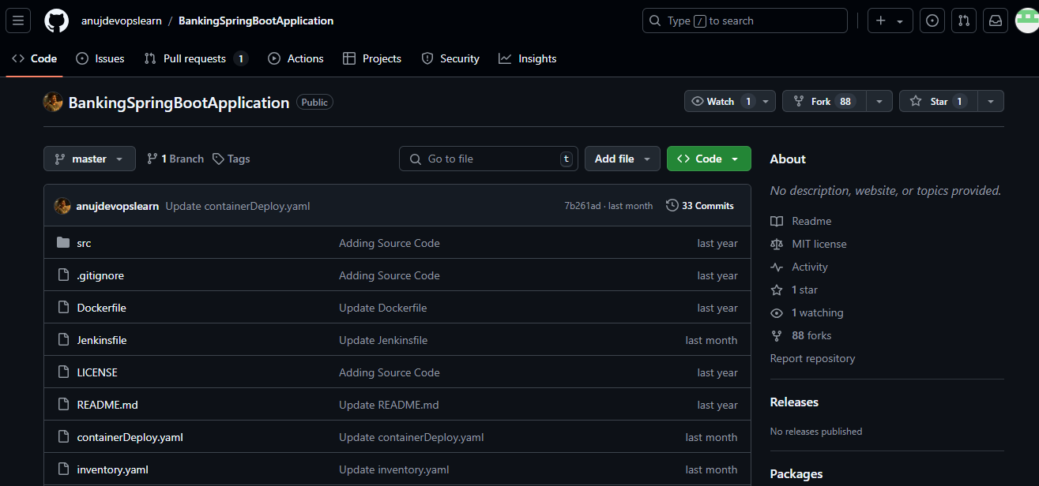

Step 2: Deploy Services on Amazon ECS
  - Navigate to the AWS Console, open the Containers menu, and select Elastic Container Service (ECS) to proceed with setting up your new ECS cluster for deploying Frontend and Backend Docker containers

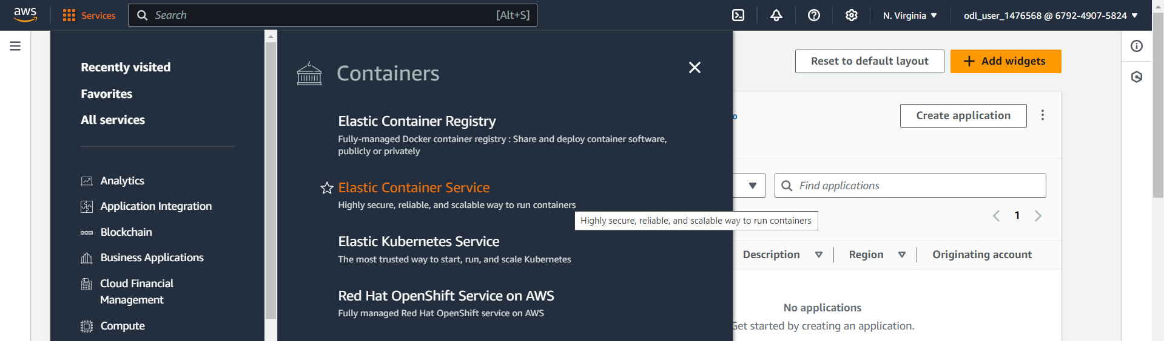

  - Click on Create cluster in the Amazon Elastic Container Service (ECS) dashboard to start the process of setting up a new cluster for deploying your Frontend and Backend Docker containers.

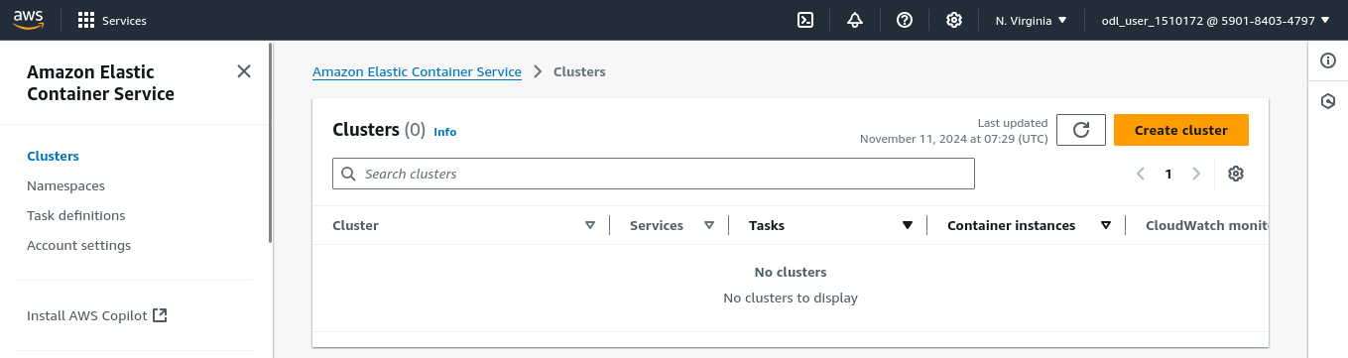

  - Enter the cluster name as DevCluster, select the default namespace, and choose AWS Fargate (serverless) as the infrastructure type to set up a serverless environment for your container deployment

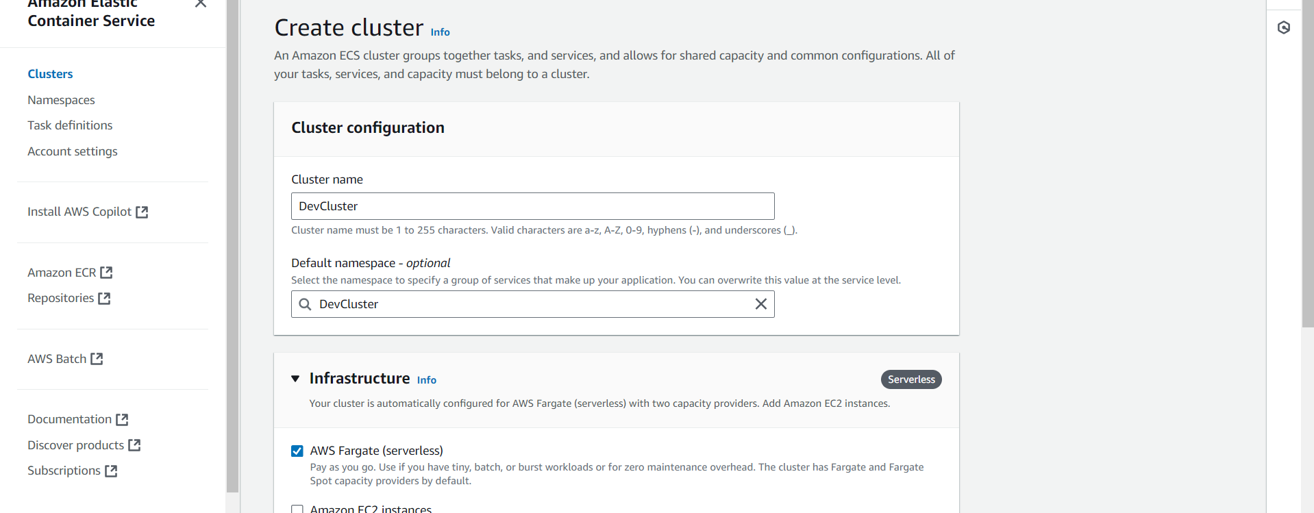

  - Confirm that the new cluster DevCluster has been successfully created and is visible in the list of clusters in the Amazon ECS dashboard.

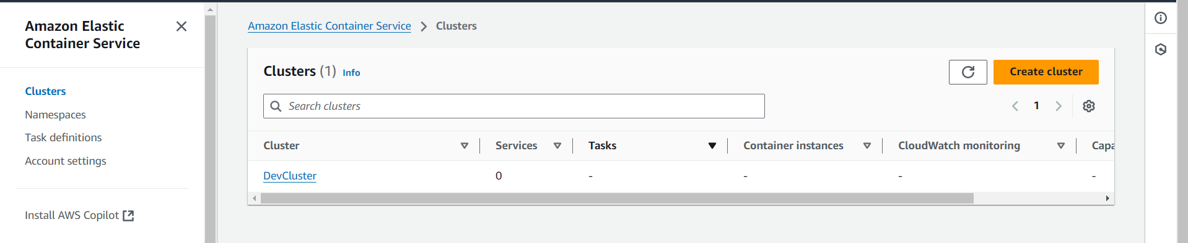

  - Verify that the cluster DevCluster is in an Active state in the cluster overview section of Amazon ECS. Check the details such as ARN, CloudWatch monitoring status, and the registered container instances before proceeding with service and task definitions

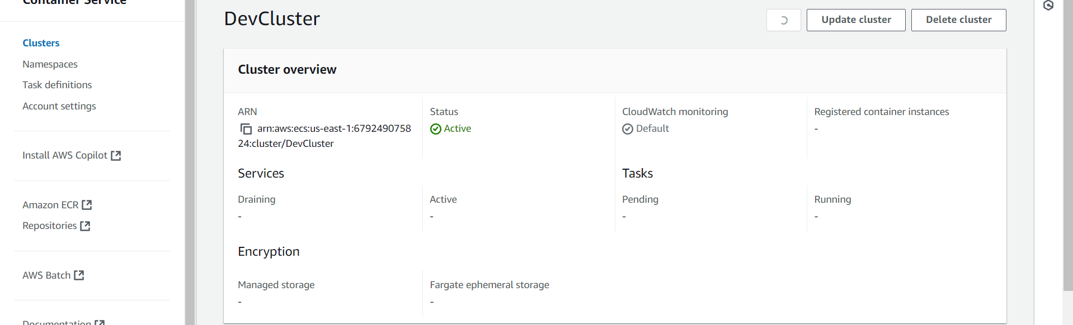
Note: We need to create task definition and basic service to start with container deployment

  - Click on Create new task definition in the Task Definitions section of Amazon ECS to start configuring a new task definition for your Docker containers, specifying details such as launch type, container definitions, and resource requirements

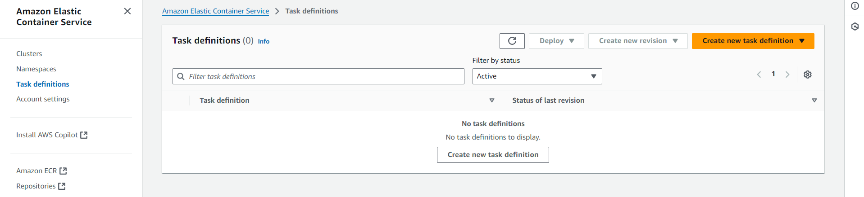

Note: Provide information regarding docker container to be deployed. We need to create two task definition one for backend and another one for frontend

  - Enter backendcontainer as the task definition family name, select AWS Fargate as the launch type, and choose the operating system as Linux/X86_64 with the network mode set to awsvpc for a serverless and secure container deployment

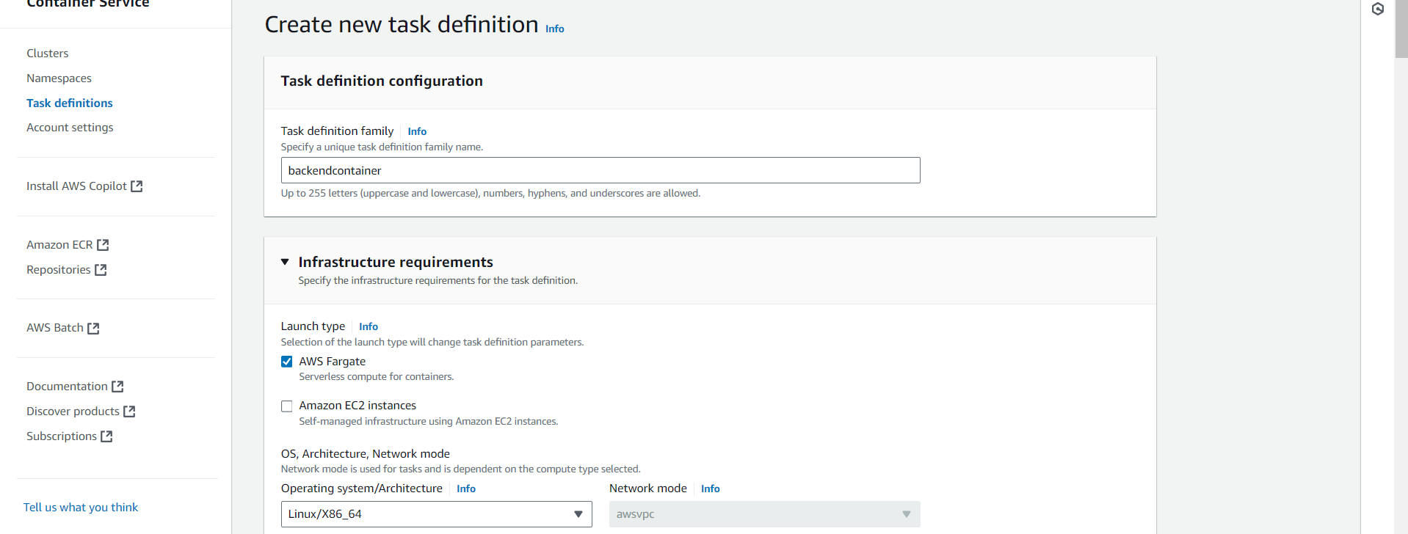

  - Set the container name to backend, use the image URI docker.io/anujsharma1990/backend:latest, mark it as Yes in Essential container, and enable port mapping with container port 3000, protocol TCP, and application protocol HTTP. Ensure that resource limits are defined as required for CPU and memory allocation.

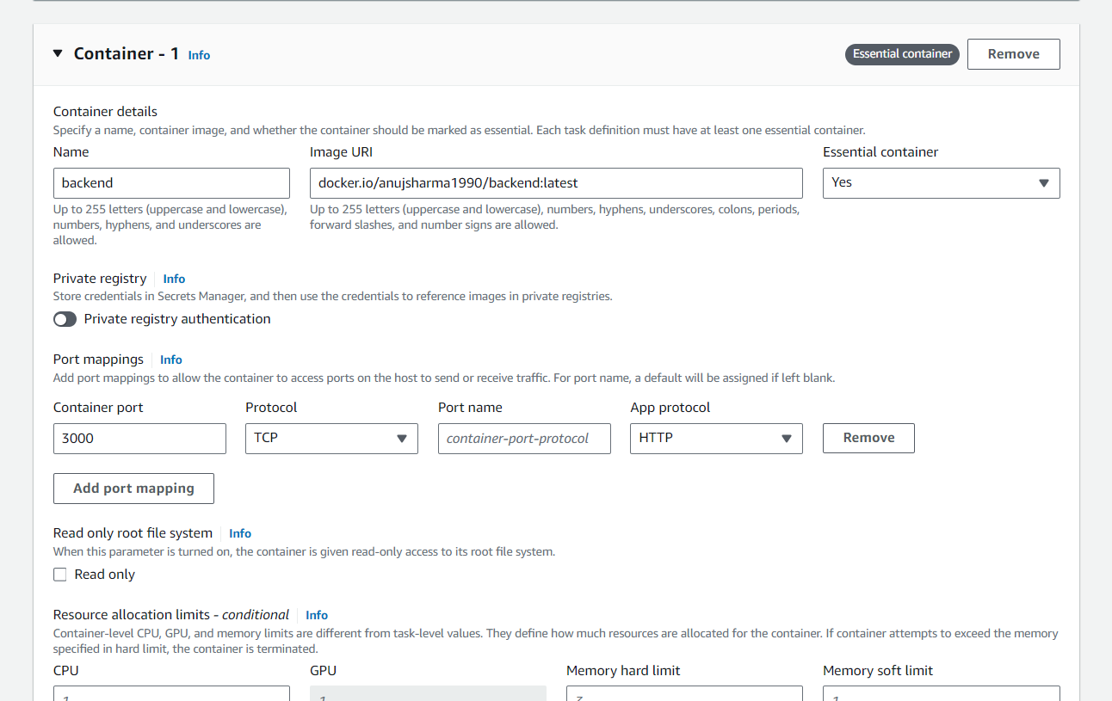

  - Click on Create to create task definition

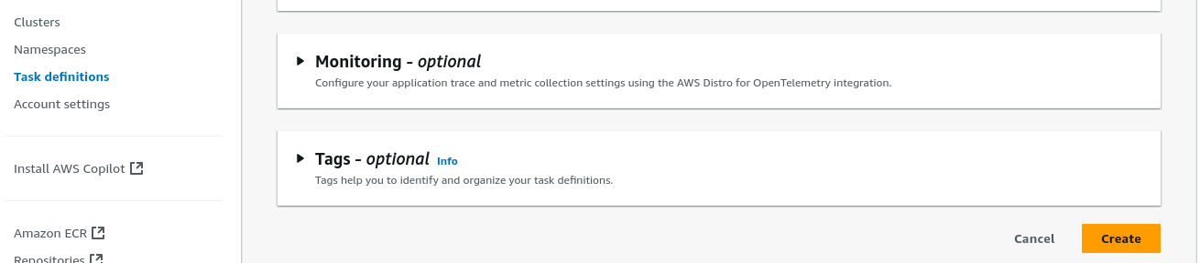

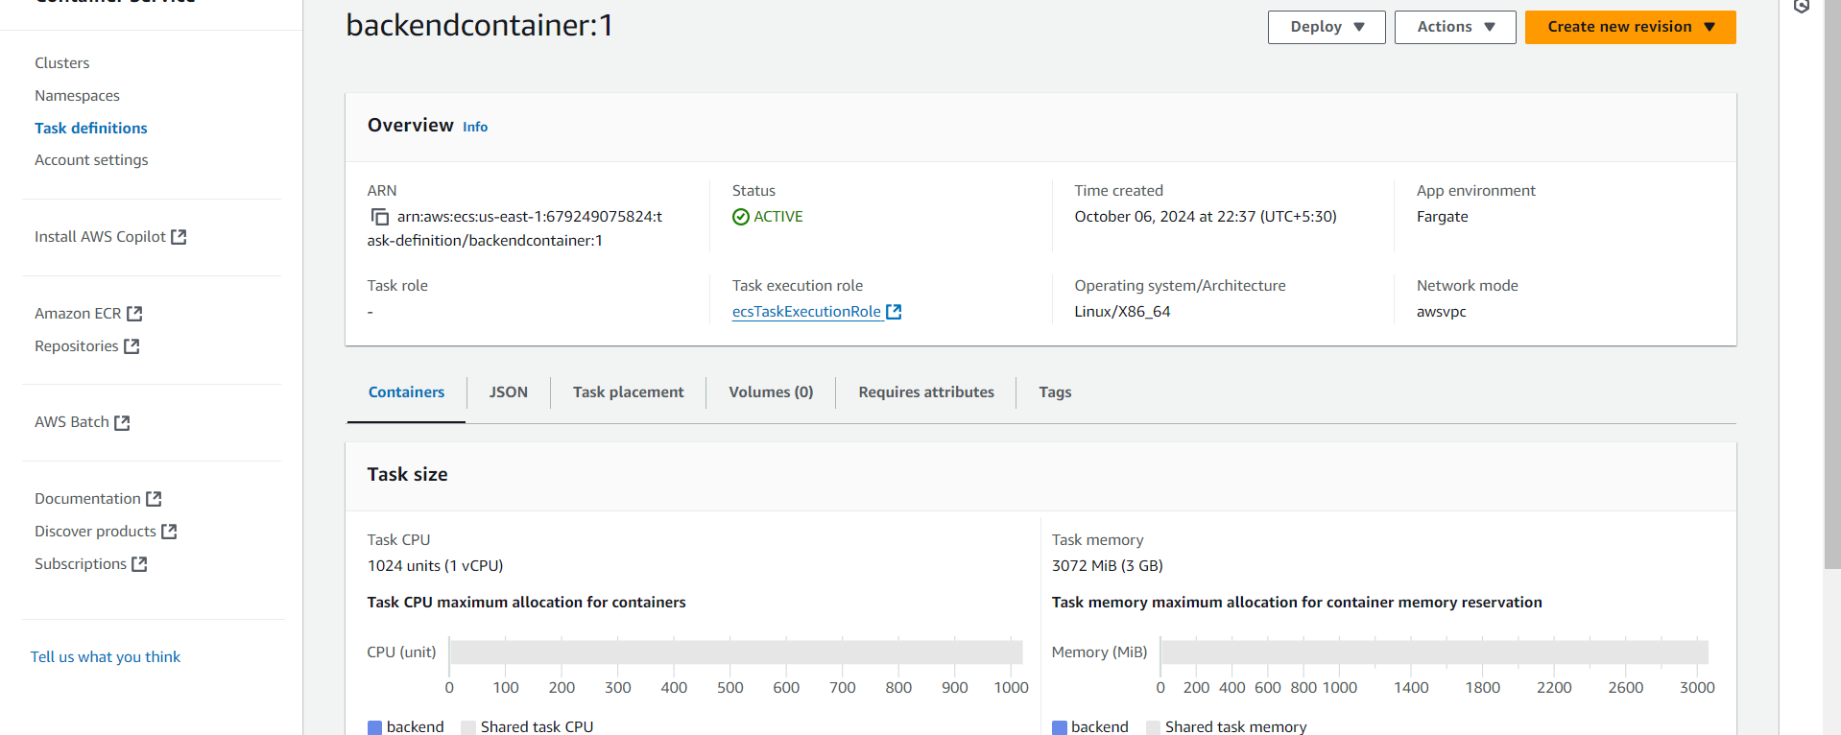

Note: Once task definition is created, we need to deploy the service.

  - Select the existing cluster DevCluster, choose Capacity provider strategy for compute configuration, and set the capacity provider to FARGATE with a weight of 1 to ensure tasks are deployed using AWS Fargate

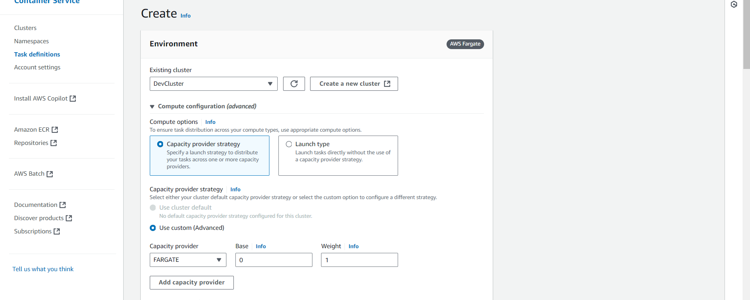

  - For the deployment configuration, select Service as the application type, choose the task definition backendcontainer with revision 1, set the service name as backend-service, and select Replica as the service type. Define the desired number of tasks as required for the deployment.

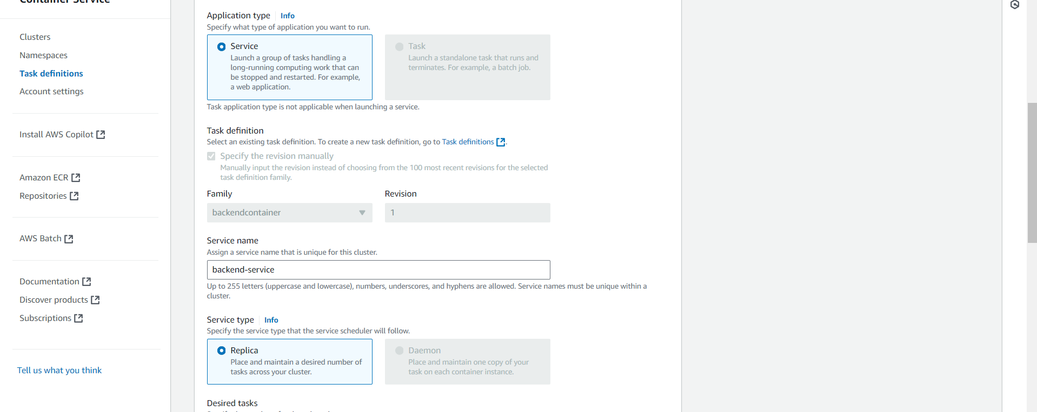

  - Choose the default VPC, select multiple subnets for high availability, and create a new security group named sg_backend_service with a description Created in ECS Console. This setup ensures secure networking and resource placement within the specified subnets

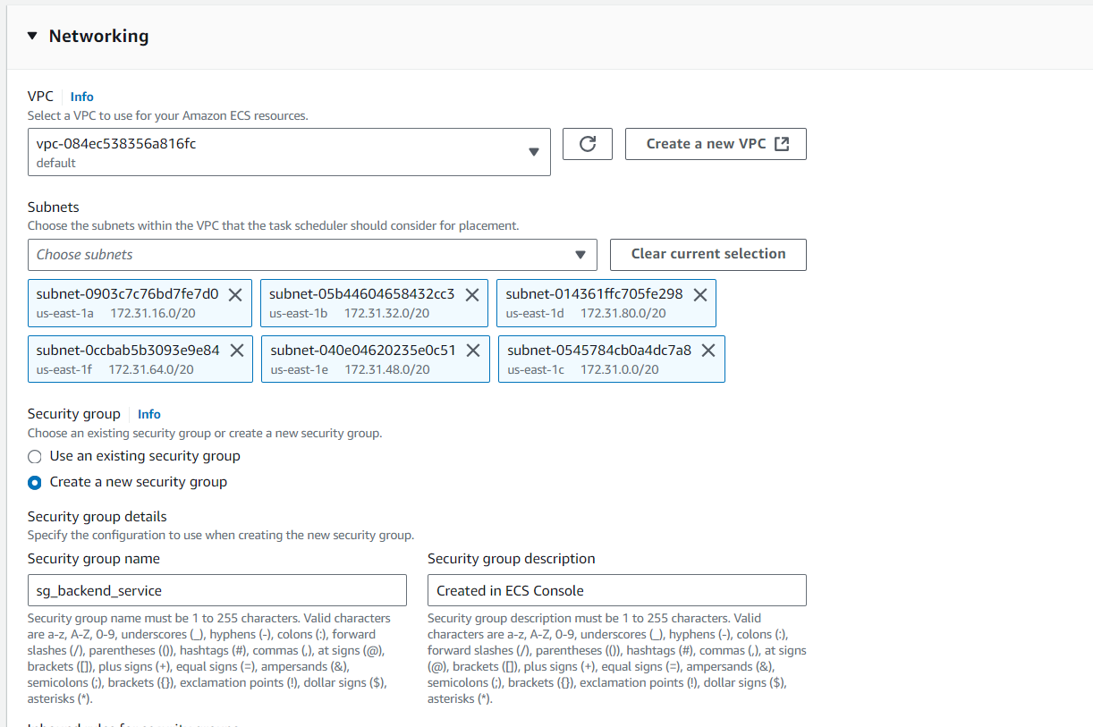

  - Set up an inbound rule in the security group sg_backend_service to allow TCP traffic on port 3000 from any source (0.0.0.0/0, ::/0) and ensure that the option for assigning a Public IP is turned on to enable external access to the backend service

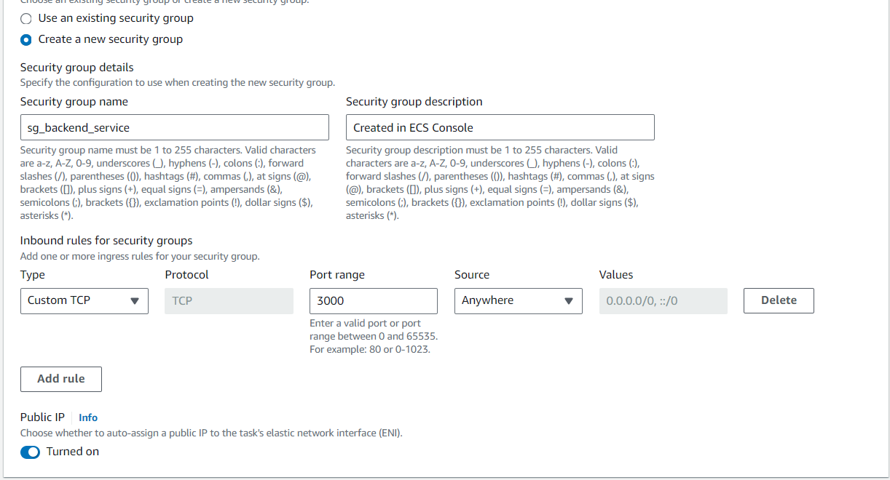

  - Confirm that the deployment of backend-service is in progress and that the cluster DevCluster is in an Active state, as indicated in the cluster overview. Monitor the status of tasks and services to ensure successful deployment and proper operation

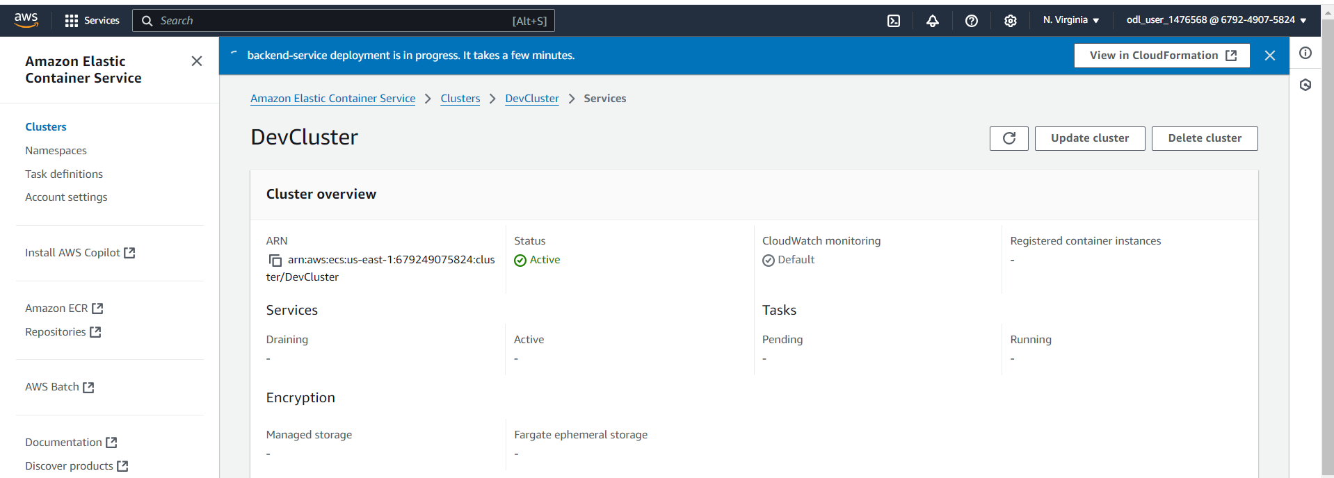

Note: We need to repeat same steps for frontend application
  - Create a new task definition named frontend, select AWS Fargate as the launch type, and set the operating system architecture to Linux/X86_64 with the network mode configured as awsvpc for a serverless and secure container environment

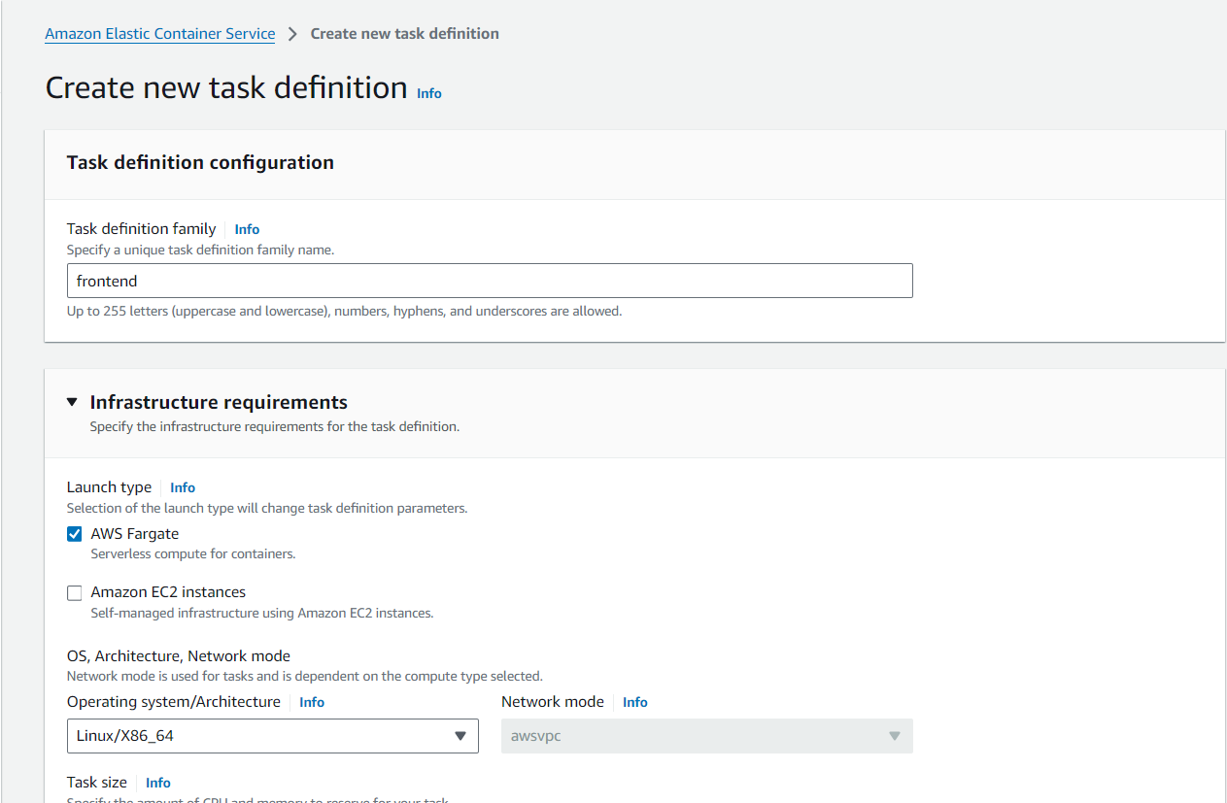

  - Set up frontend-container with image URI docker.io/anujsharma1990/frontend:latest, mark it as essential, configure port 80 with TCP and HTTP protocols, and allocate resources with 1 CPU, 1 GPU, a hard memory limit of 3 GB, and a soft limit of 1 GB

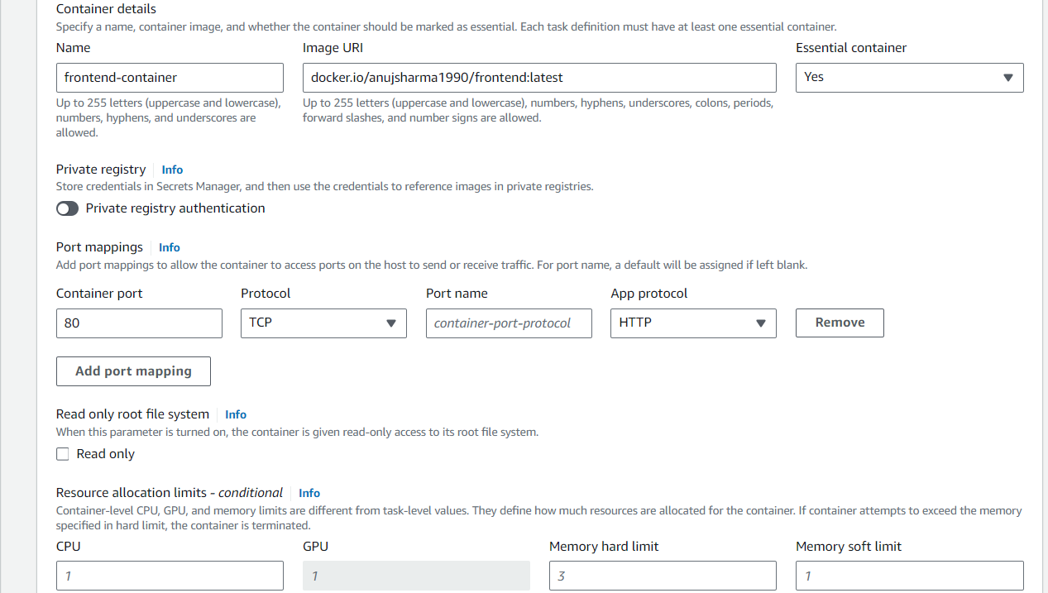
Confirm that the task definition frontendfro:1 has been successfully created and is in an Active state, with 1 vCPU, 3 GB memory, using Fargate launch type, Linux/X86_64 architecture, and awsvpc network mode, ready for deployment

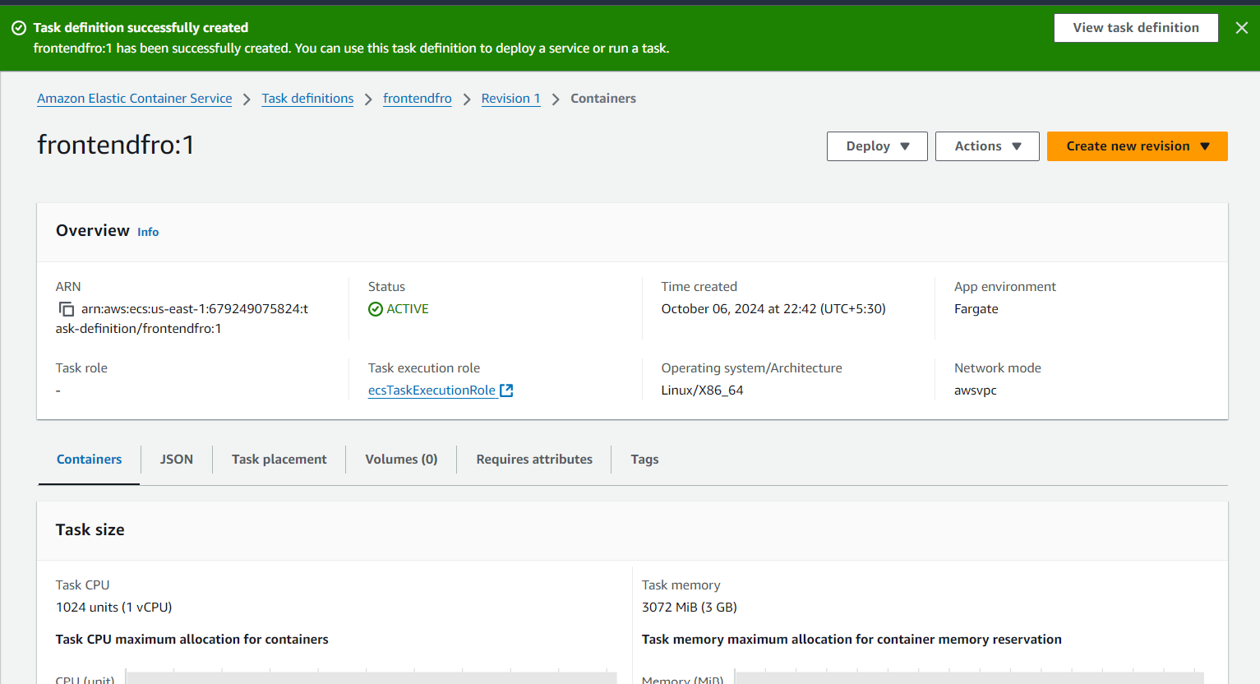

  - Choose Service as the application type, select the task definition frontendfro with revision 1, set the service name to frontend-service, and choose Replica as the service type to maintain the desired number of tasks in the cluster.

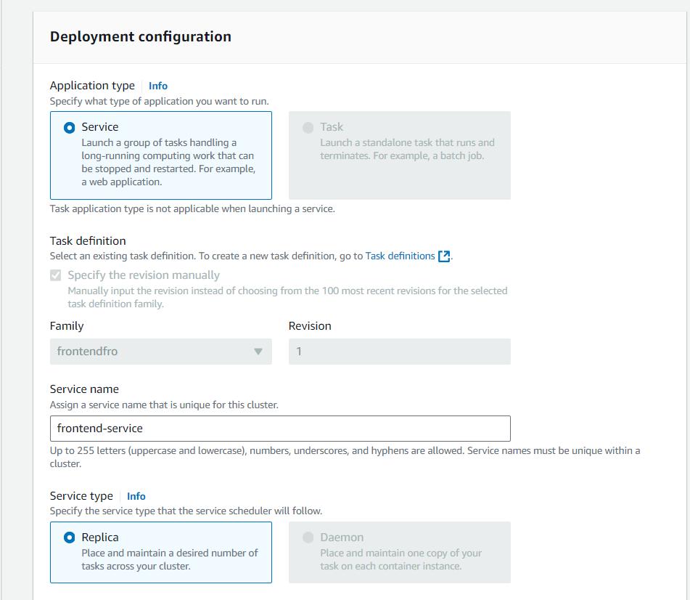

  - Create a new security group named sg_frontend_security with a description Created in ECS Console, add an inbound rule to allow TCP traffic on port 3000 from any source (0.0.0.0/0, ::/0), and ensure that the option for assigning a Public IP is turned on.

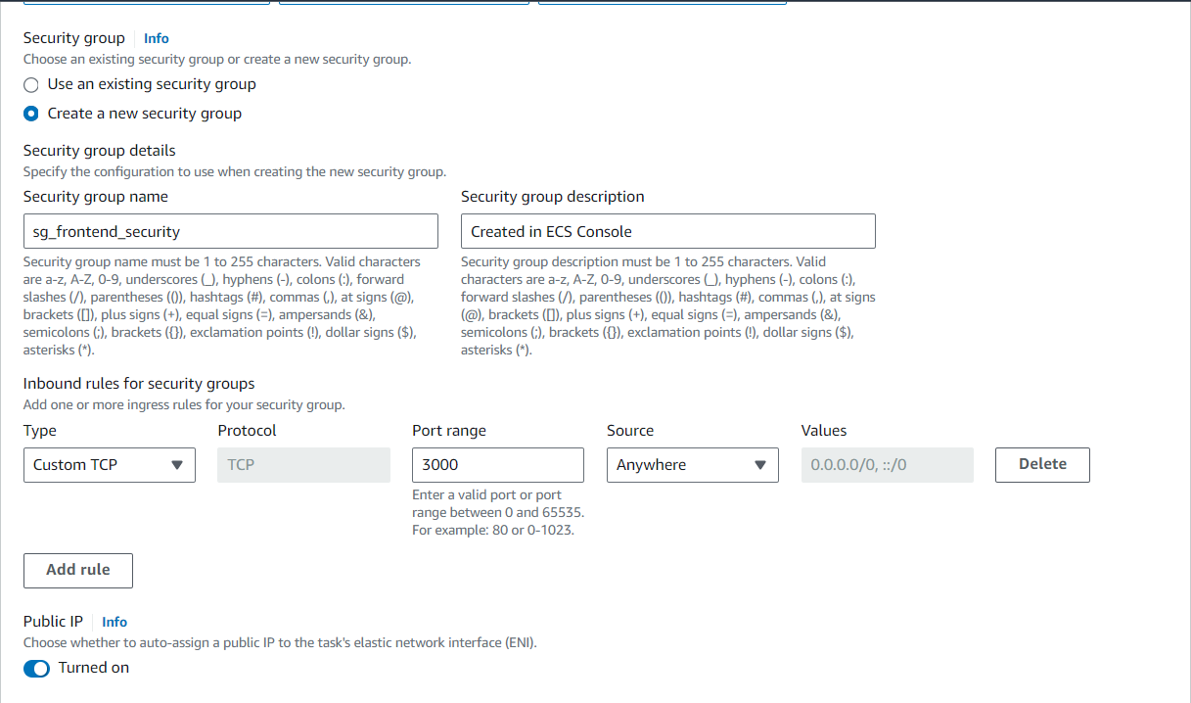

Once both backend and frontend services are created you can see them created as per below screenshot.

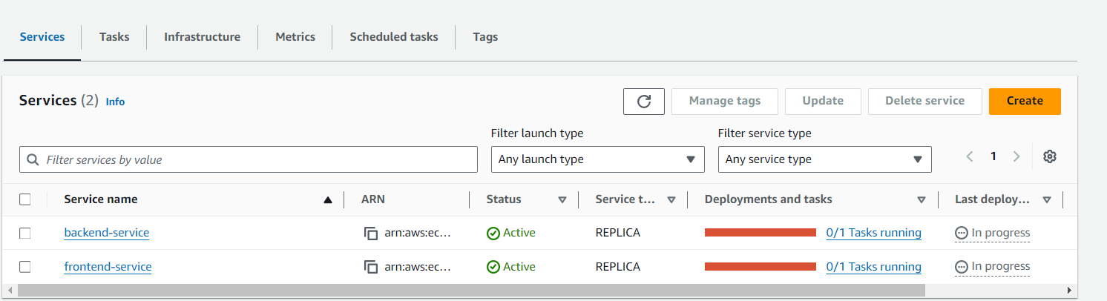

Step 3: Automate CI/CD with AWS CodePipeline
Note: Once cluster is provisioned, we can proceed with configuring AWS Code pipeline to automate CI CD workflow
  - Navigate to the AWS Management Console, go to Developer Tools, and select CodePipeline to start configuring your continuous delivery pipeline for software release.

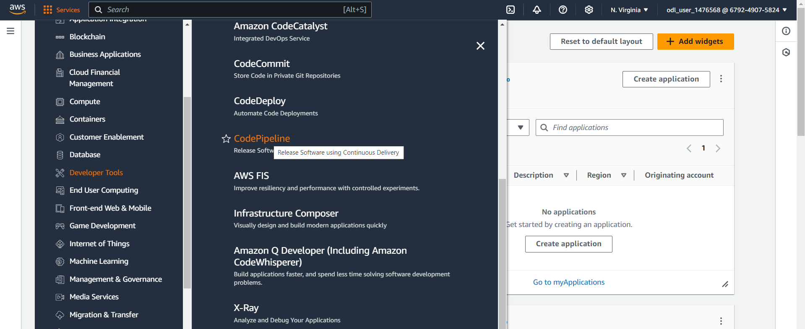

  - Click on Create pipeline in the CodePipeline dashboard to begin setting up a new continuous delivery pipeline.

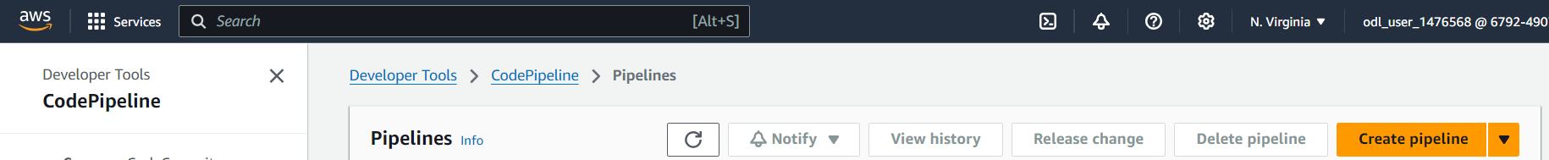

  - Set the Pipeline name to BackendPipeline, select the pipeline type as V2, and choose the Queued execution mode for processing executions in the order they are triggered.

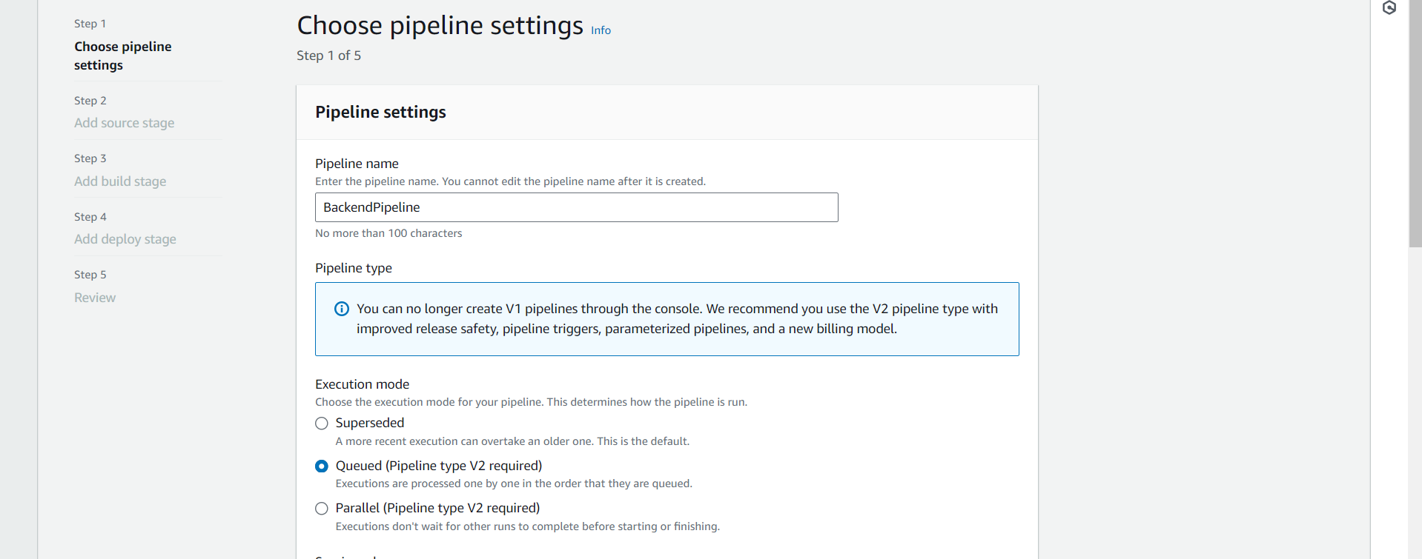

  - Set Source provider to GitHub (Version 2), click Connect to GitHub to create a connection, specify the Connection, input the Repository name, and select the Default branch for the source stage.

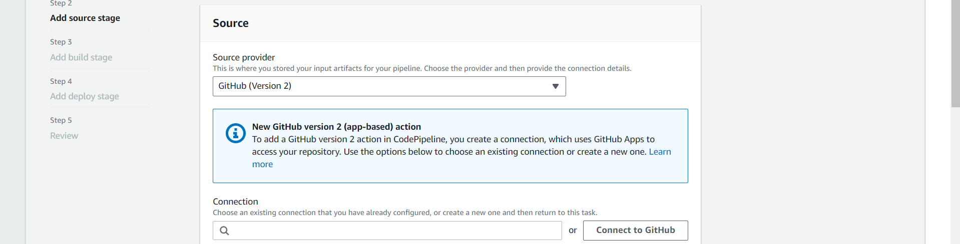

  - Enter the Connection name as connection, add optional Tags if needed, and click Connect to GitHub to proceed with creating the GitHub App connection

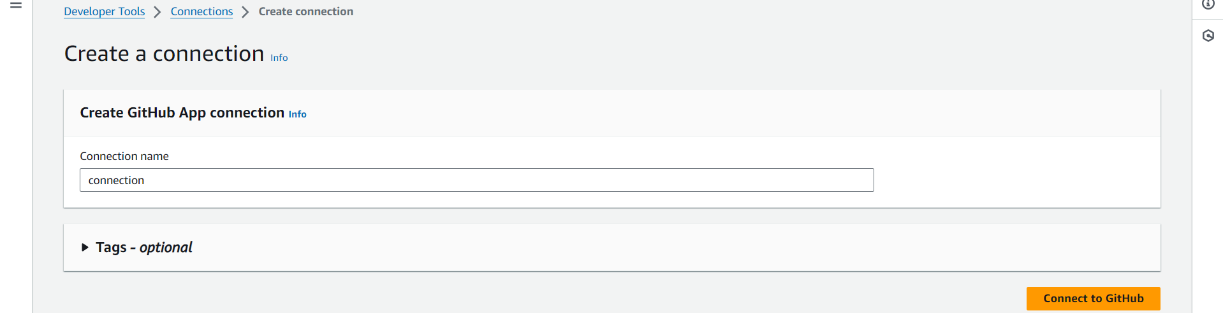

  - Click Authorize AWS Connector for GitHub to grant permissions for verifying GitHub identity, accessing resources, and acting on your behalf, completing the integration between AWS and GitHub

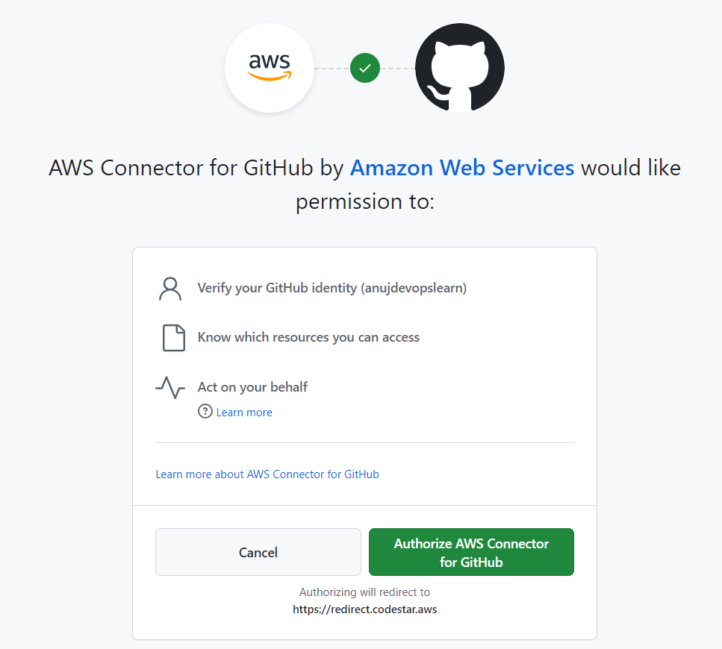

  - Ensure the Connection name is set to connection, select the App installation with ID 17235361, and click Connect to finalize the GitHub connection setup in AWS

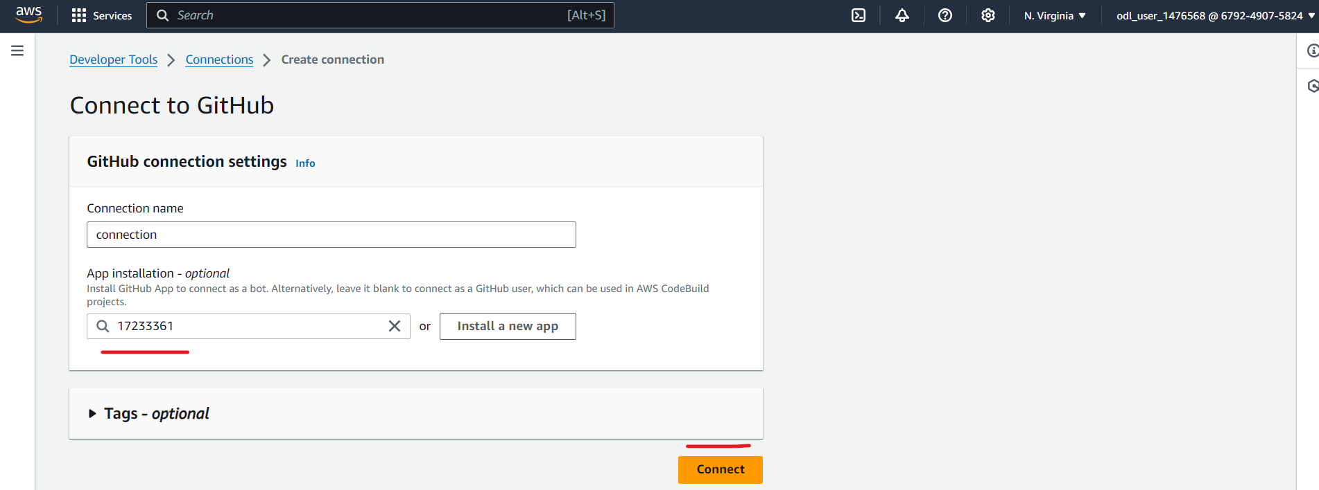

  - Confirm the GitHub connection, set the Repository name to anujdevopslearn/NodeBackend, select master as the Default branch, and choose CodePipeline default for the output artifact format.

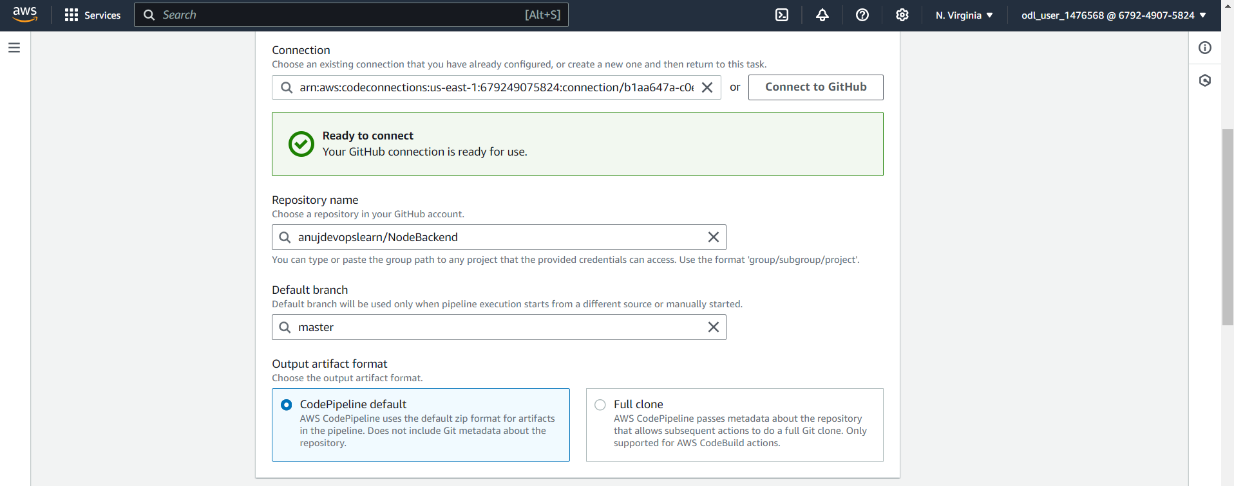

Keep the default trigger configurations and continue to the next step

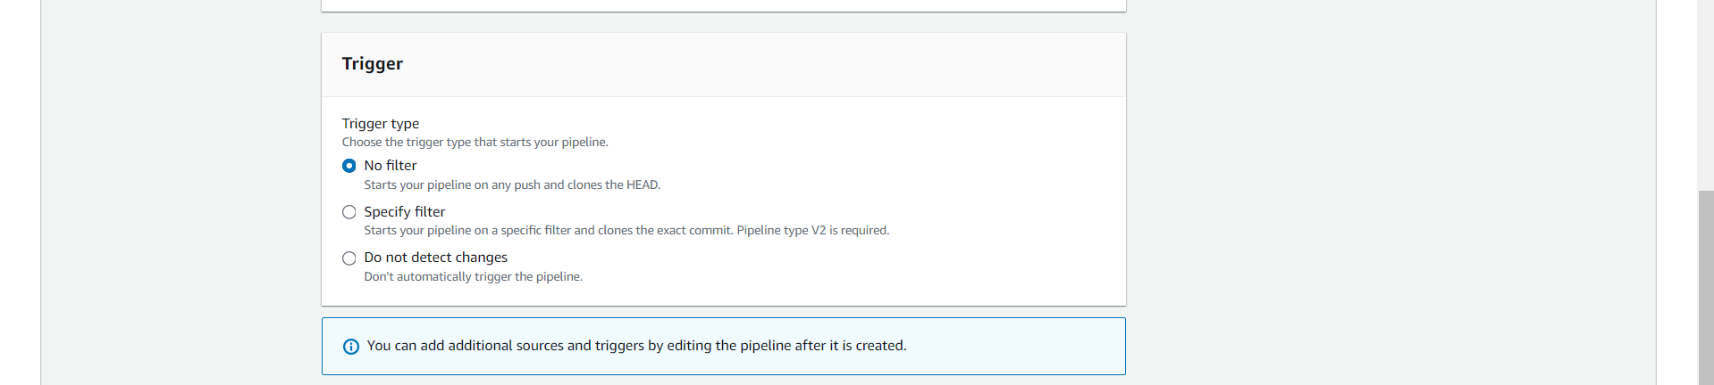

  - Choose Other build providers, select AWS CodeBuild as the build provider, click Create project to define a new build project, and select Single build as the build type

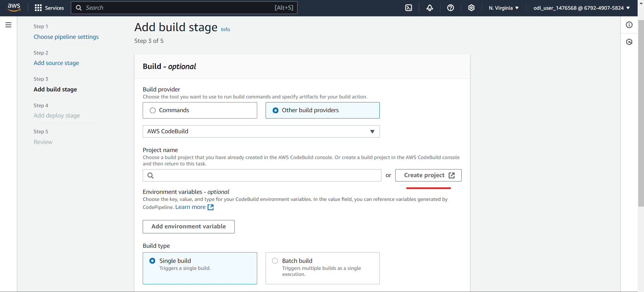

  - Enter the Project name as BuildProject, select On-demand for the provisioning model, and choose Managed image for the environment image to use an AWS CodeBuild managed image

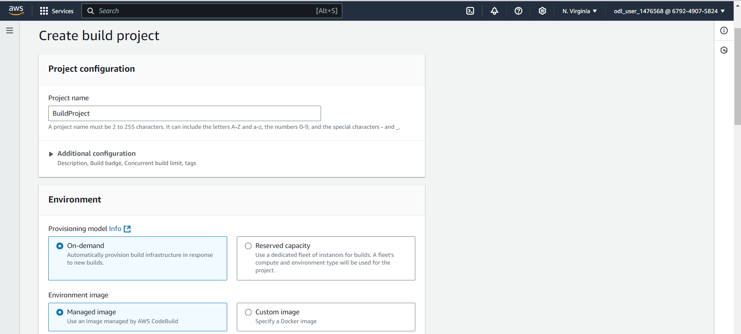

  - Select On-demand for the provisioning model, choose Managed image for the environment image, set EC2 for compute, select Amazon Linux as the operating system, choose Standard for runtime(s), and pick the image aws/codebuild/amazonlinux2-x86_64-standard:5.0

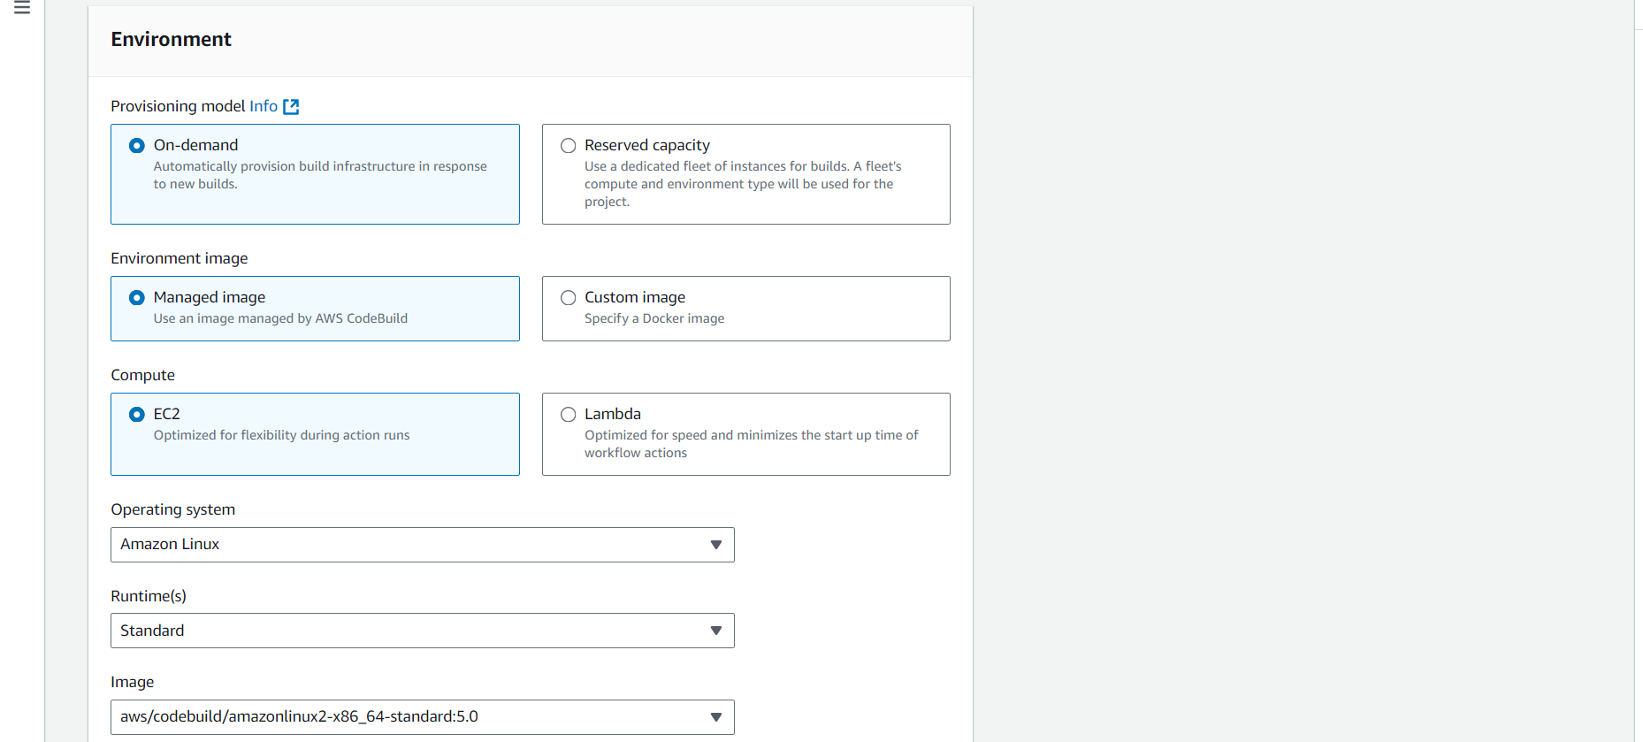

  - Select New service role, set the role name to codebuild-BuildProject-service-role, configure the timeout to 1 hour, set the queued timeout to 8 hours, and enable the Privileged flag for elevated build permissions if needed

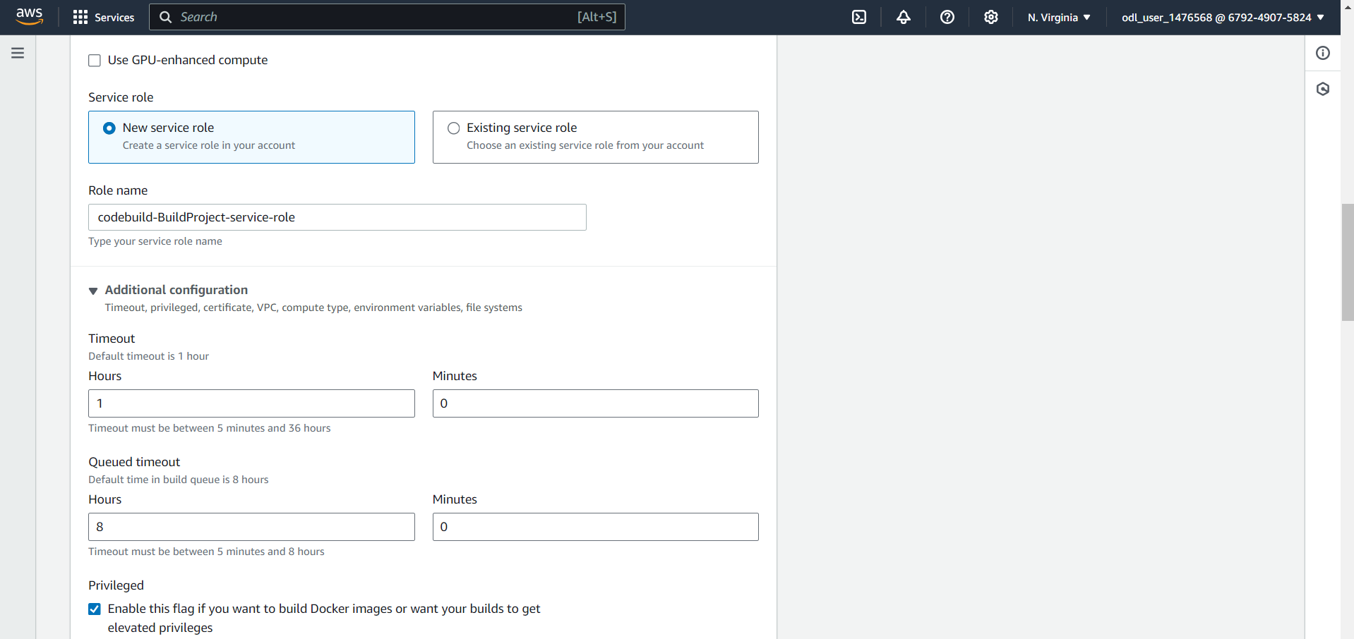

  - Choose Use a buildspec file, specify the buildspec name as buildspec.yml, and optionally enable CloudWatch logs for build output monitoring

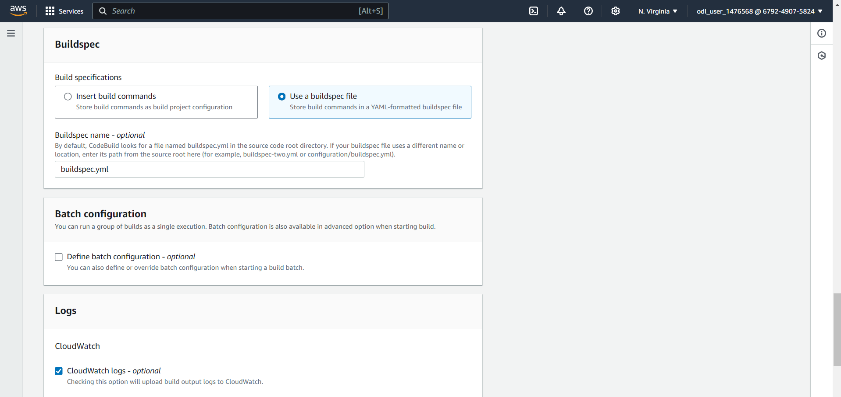

  - Choose project name and then proceed with adding environment variables for connecting with Docker hub

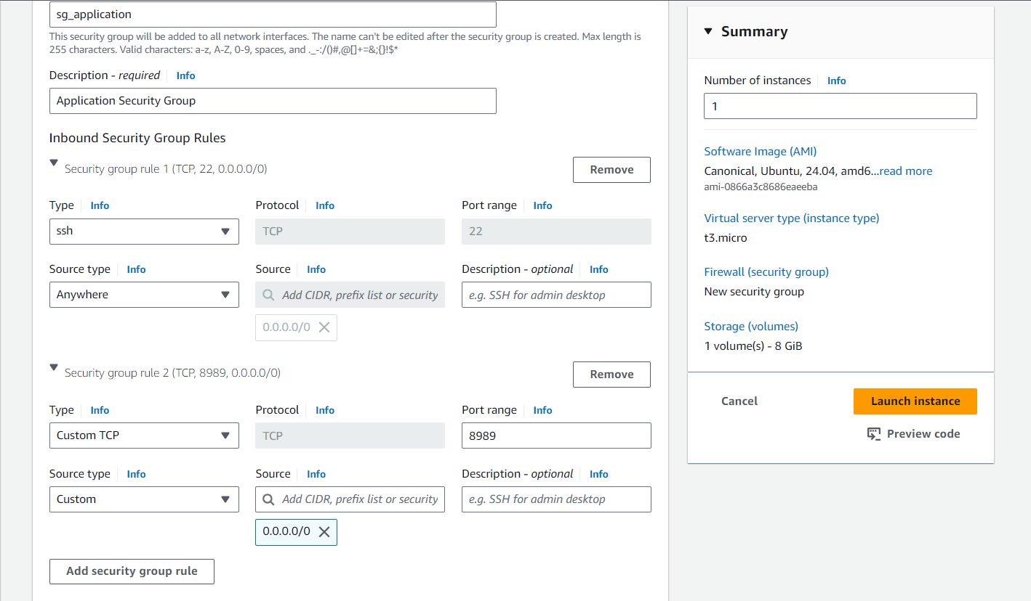

  - Confirm that BuildProject is successfully created, select it as the Project name, and choose Single build for the build type to proceed with the build stage setup in CodePipeline

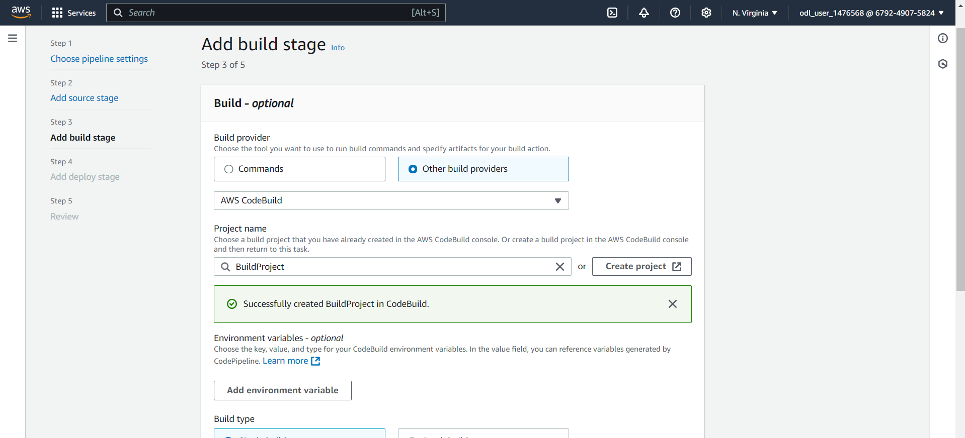

  - Click on Add environment variable and add variables as per below screenshot

  - Navigate to Docker hub and create a new free account and keep Docker hub username and password with you before configuring Jenkins credential
https://hub.docker.com/

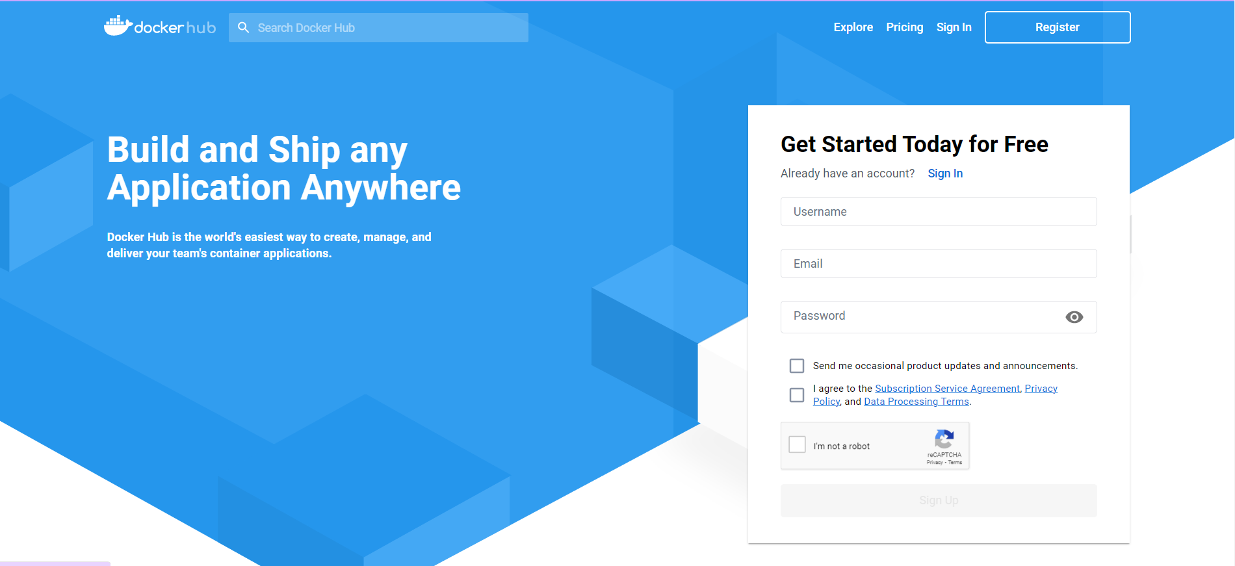

  - Set the Deploy provider to Amazon ECS, choose the Region as US East (N. Virginia), select BuildArtifact as the input artifact, set the Cluster name to DevCluster, and specify the Service name as backend-service

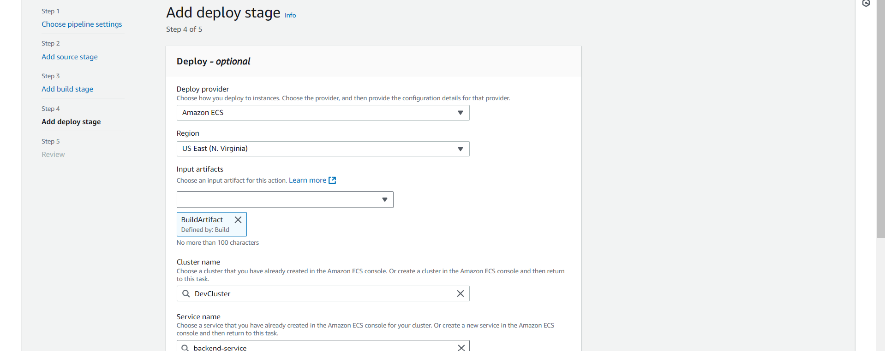

  - Set the Service name to backend-service, specify the image definitions file as imagedefinition.json, leave the Deployment timeout optional, and click on Next

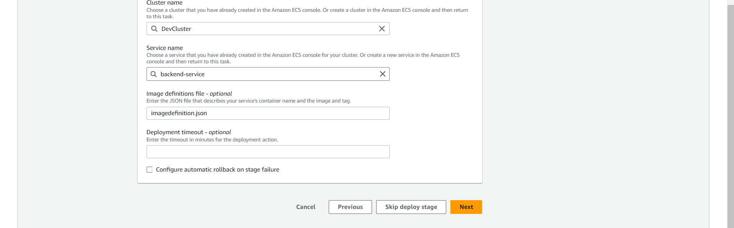

Note: Initial Pipeline execution would be failure since we do not have buildspec.yml stored in Backend repository, we must proceed with that

  - Navigate to Backend repository on GitHub and create buildspec.yml using below content

version: 0.2
phases:
pre_build:
commands:
- echo Logging in to DockerHub...
- docker login -u $DOCKERHUB_USER -p $DOCKERHUB_PASS
- REPOSITORY_URI="docker.io/anujsharma1990/backend"
- CONTAINER_NAME="backend-container"
- IMAGE_TAG="latest"
build:
commands:
- echo Build started on `date`
- echo Building the Docker image...
- docker build -t $REPOSITORY_URI:$IMAGE_TAG .
post_build:
commands:
- echo Build completed on `date`
- docker push $REPOSITORY_URI:$IMAGE_TAG
- echo Writing image definitions file...
- printf '[{"name":"'$CONTAINER_NAME'","imageUri":"%s"}]' $REPOSITORY_URI:$IMAGE_TAG > imagedefinition.json
artifacts:
files: imagedefinition.json

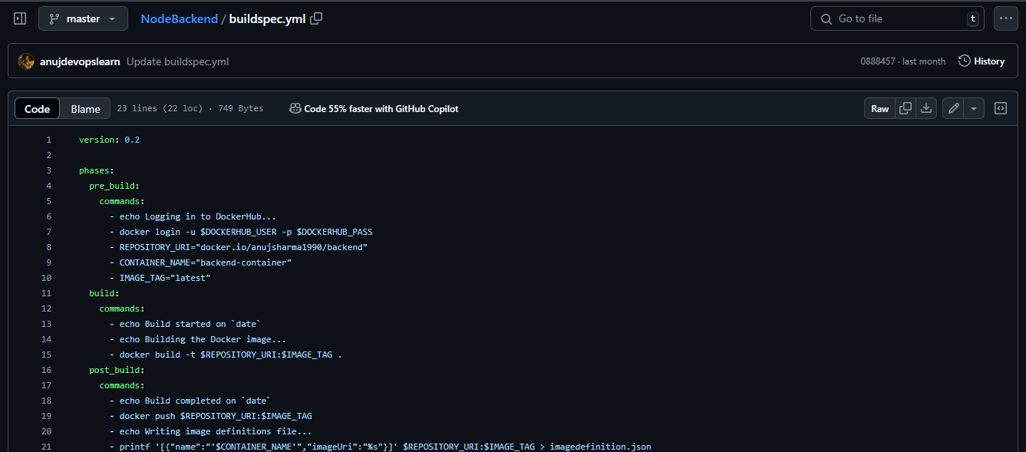

Once file is created Code pipeline would be invoked automatically

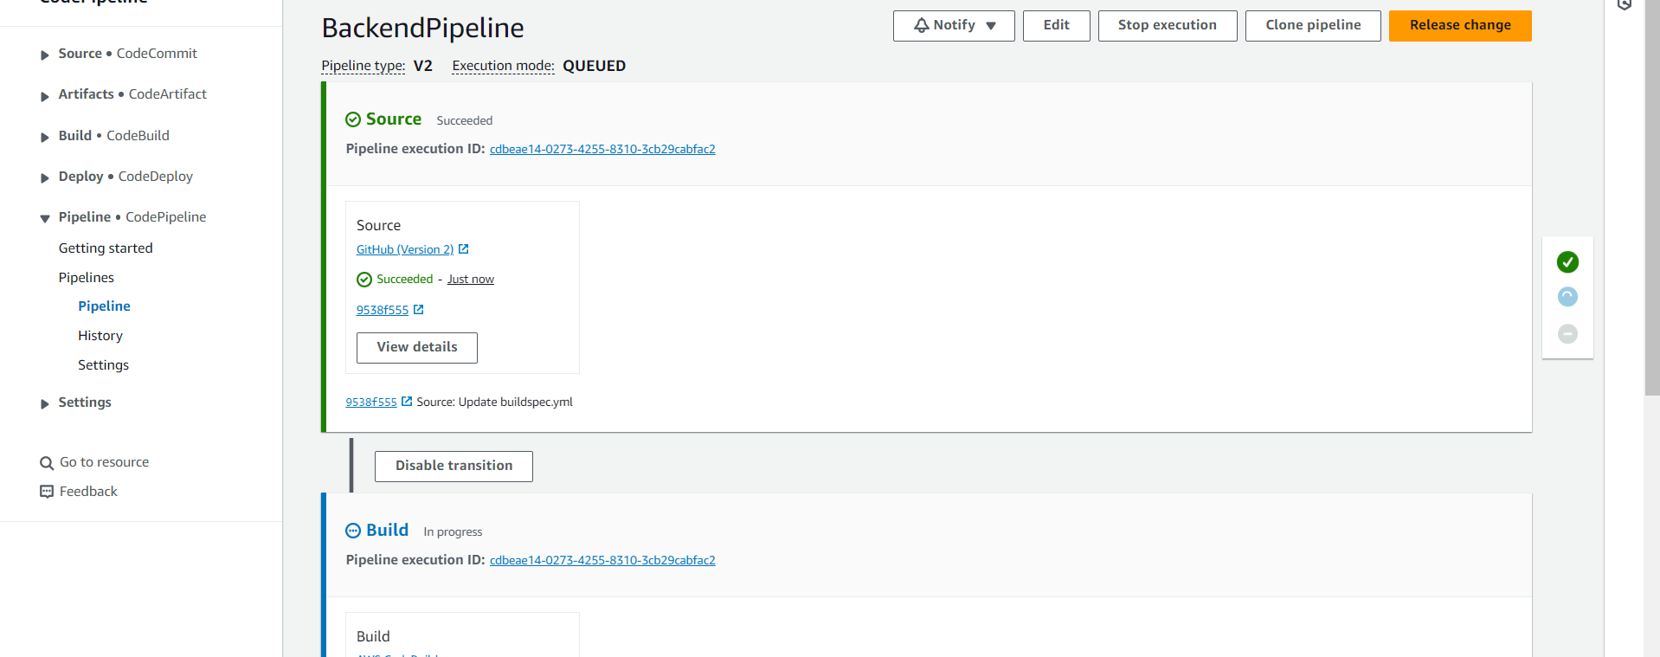

Once Deploy stage is successful you can see if service is deployed successfully on ECS Cluster

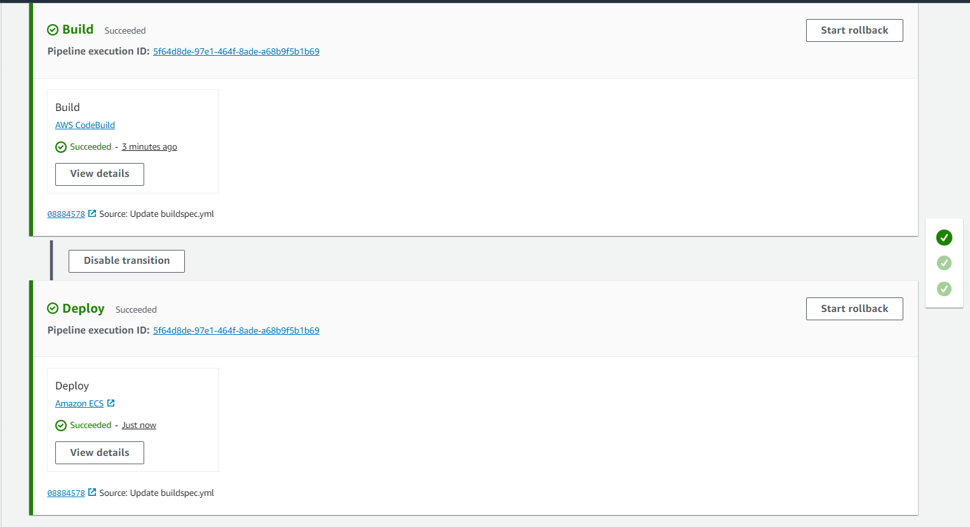

Backend Service is up and running post deployment which confirms deployment worked

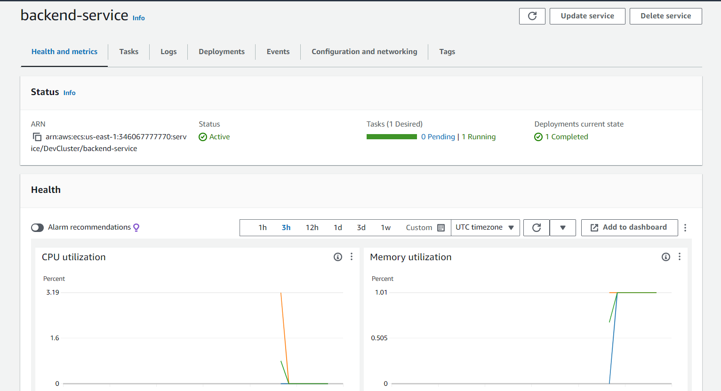

  - Navigate to Tasks tab and select running task. Under networking tab, you will be able to access Public IP using which you can access Backend API

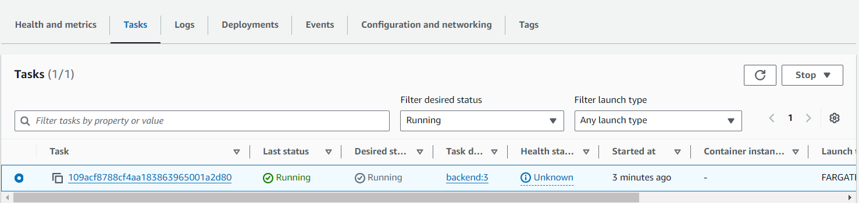

  - Use Public IP address and URL as below to access backend application
http://<public-ip>:3000/testAPI

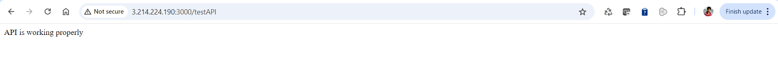

Once Backend pipeline is configured, we need to follow same steps with Frontend application also

  - Set the Pipeline name to FrontendPipeline, select V2 for the pipeline type, choose Queued for the execution mode, and opt for New service role for the service role configuration.

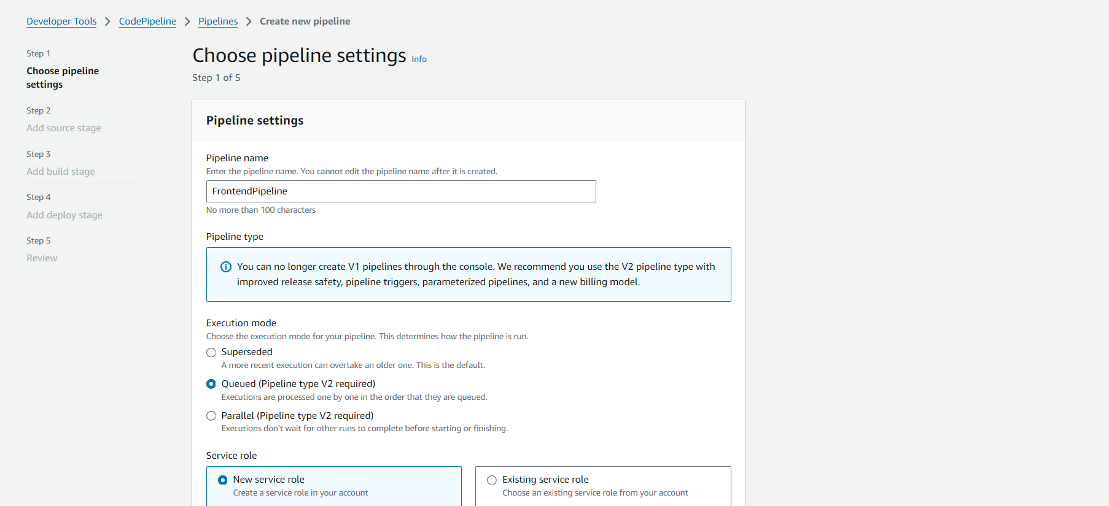

  - Set the Source provider to GitHub (Version 2), confirm the connection with the provided ARN, use anujdevopslearn/ReactFrontend as the Repository name, and specify the default branch as needed.

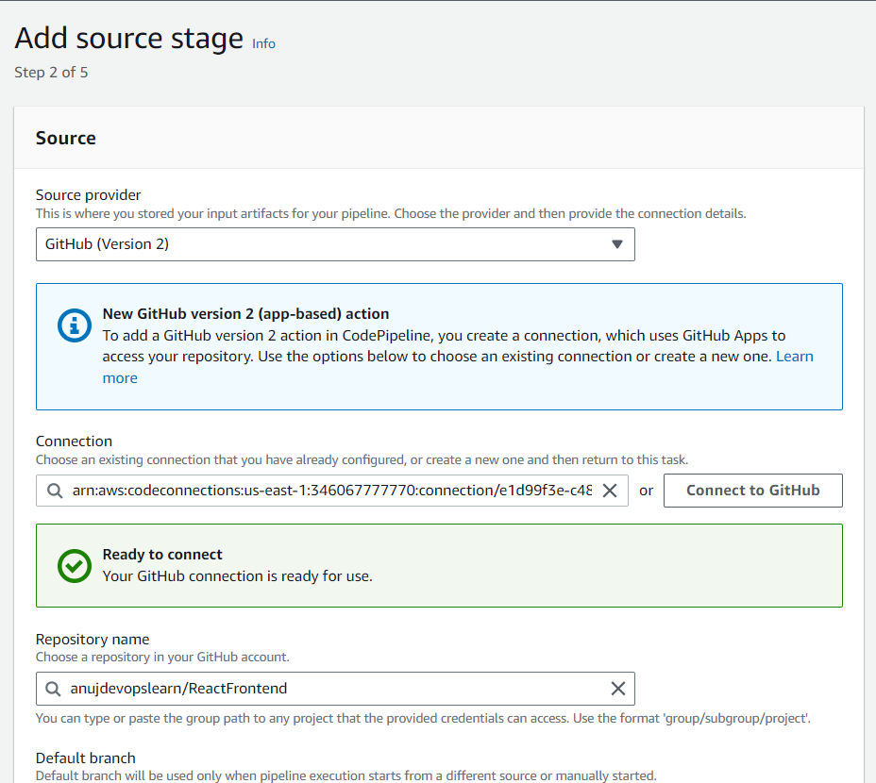

  - Set the Default branch to master, choose CodePipeline default for the output artifact format, and select No filter as the trigger type to start the pipeline on any push and clone the HEAD.

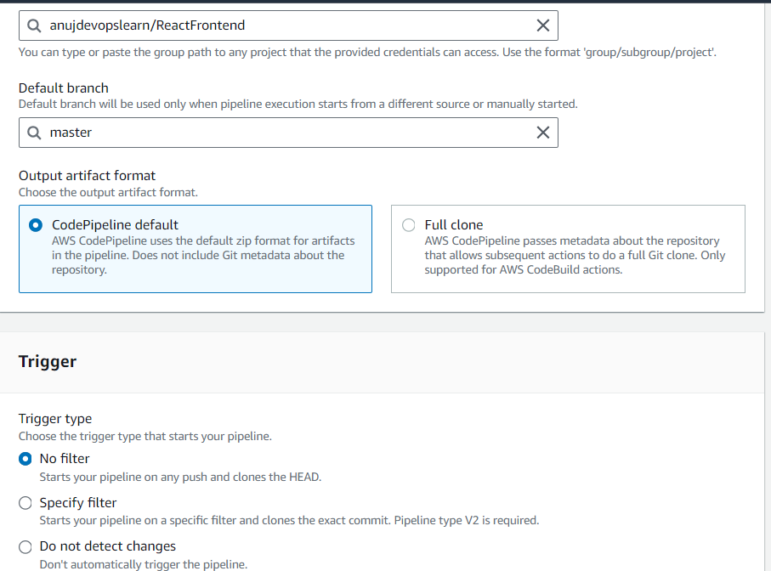

  - Select Use a buildspec file, set the Buildspec name to buildspec.yml, and optionally enable CloudWatch logs for monitoring build outputs

Once a Code build project is created navigate to Deploy stage to ECS Cluster.

  - Select the Region as US East (N. Virginia), choose BuildArtifact as the input artifact, set the Cluster name to DevCluster, specify the Service name as frontend-service, use builddefinition.json for the image definitions file, leave the Deployment timeout optional, and enable Configure automatic rollback on stage failure if needed

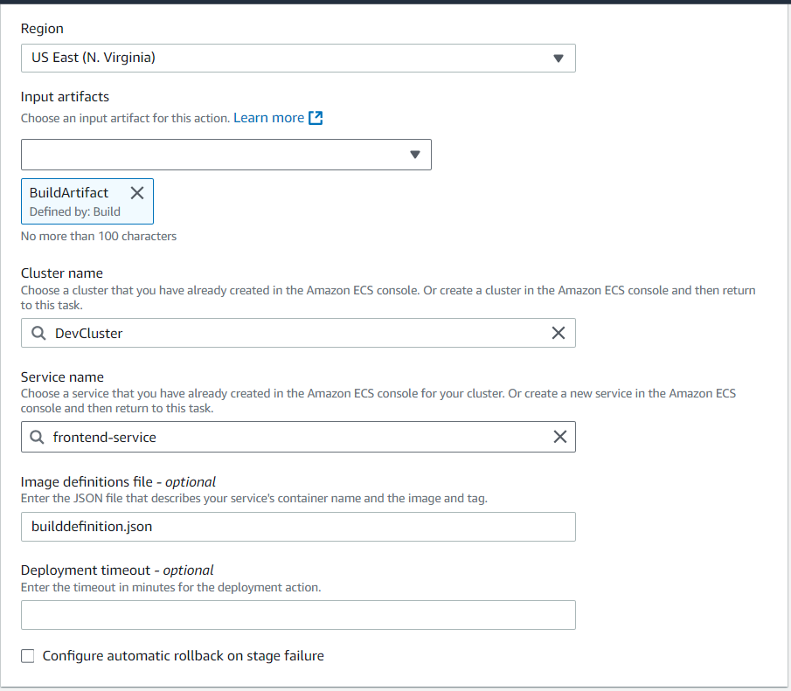
  - We need to modify .env file where backend API URL will be added

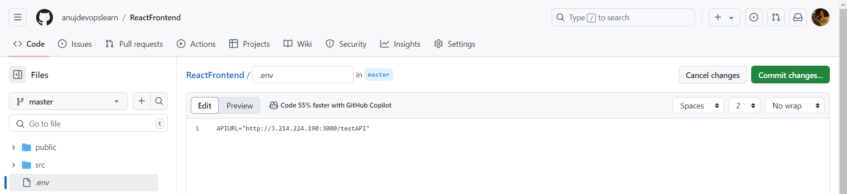

Once the build spec file is created, you will see pipeline getting invoked automatically.
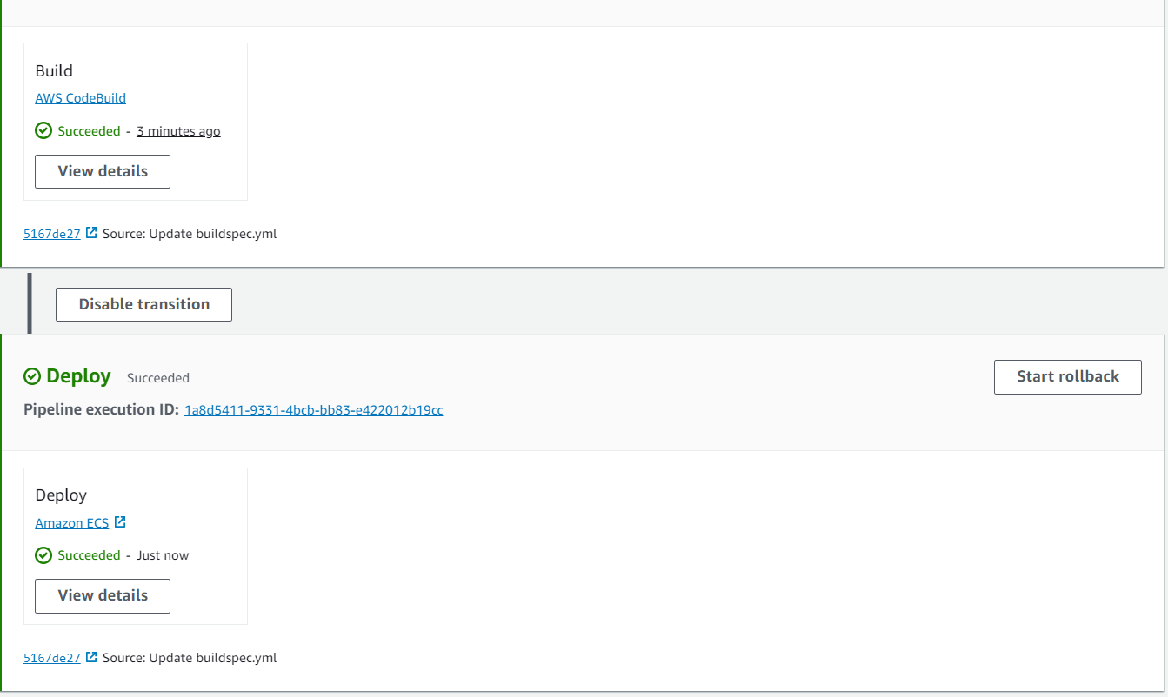
  - Once pipeline is successful, we can see both backend and frontend tasks deployed on ECS cluster and up and running
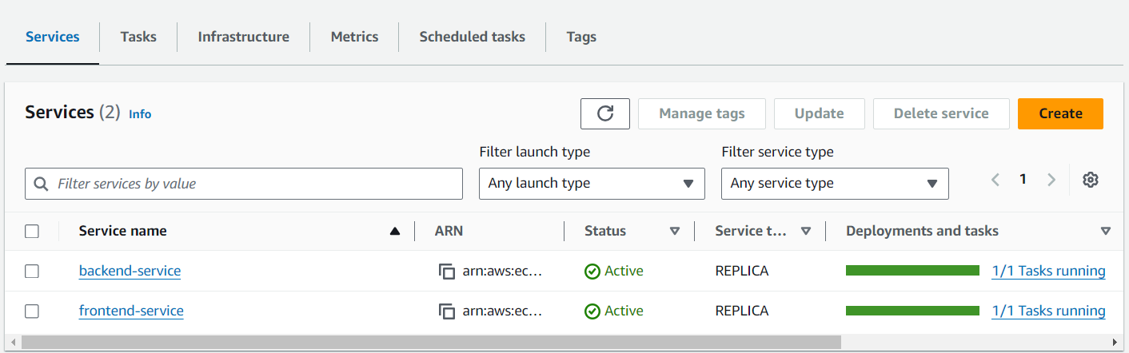
Navigate to frontend service and select task which you want to access.
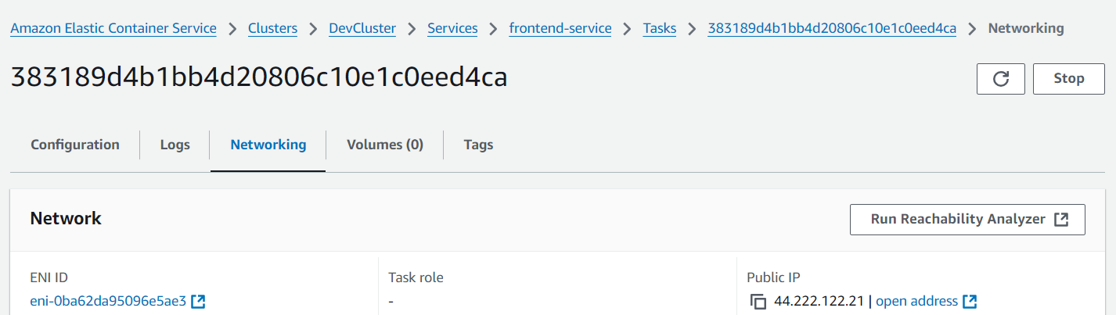
  - Use system default browser to access application deployed on Docker container frontend application
http://<public-ip>:3000

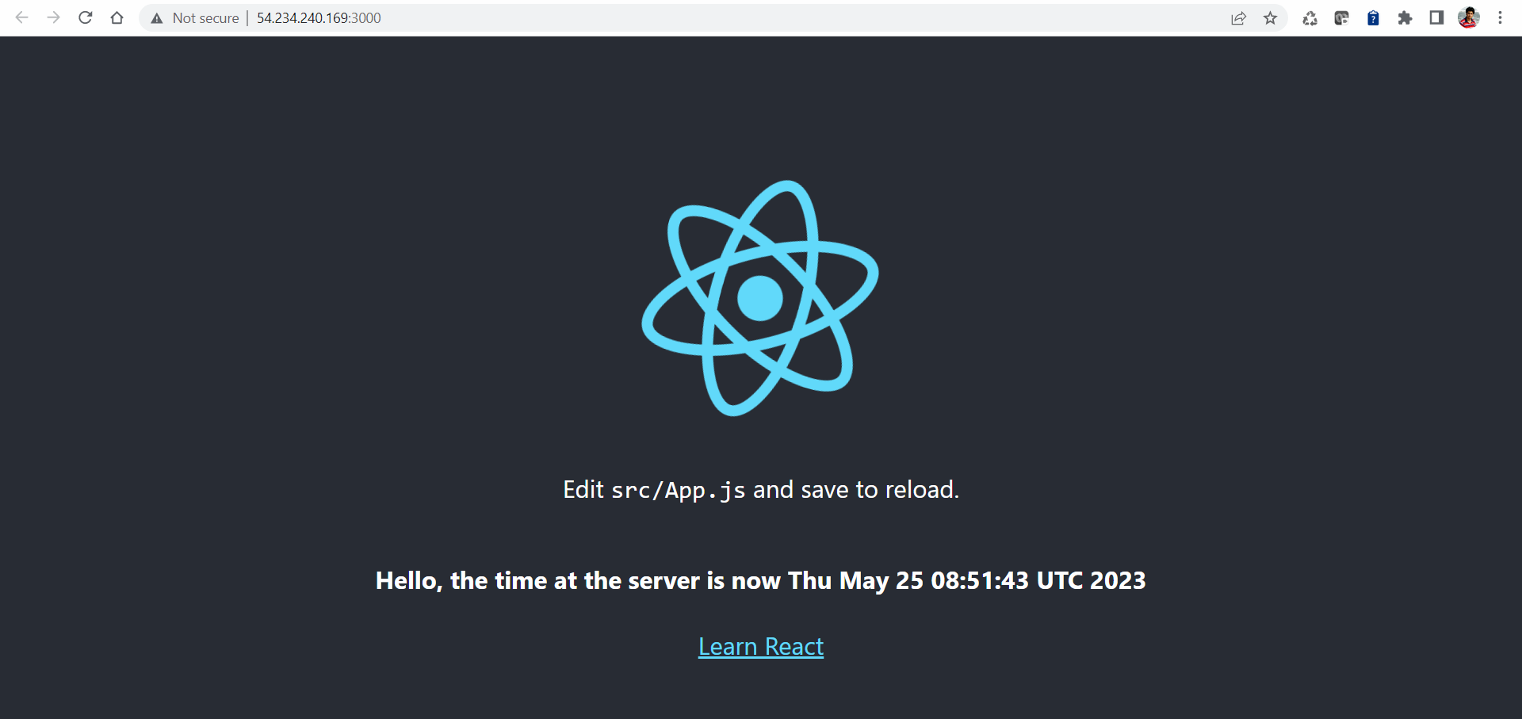

By following the above steps, you have successfully implemented microservices architecture using AWS CodePipeline and ECS, enabling automated CI/CD for seamless deployment of both backend and frontend applications, ensuring they are up and running on the ECS cluster with full integration and public accessibility.

